CVS Minute Clinic provides mental health treatment that is skilled, affordable, and easily accessible…...almost instantly. Maybe this is the support you have been wanting. Check it out today. 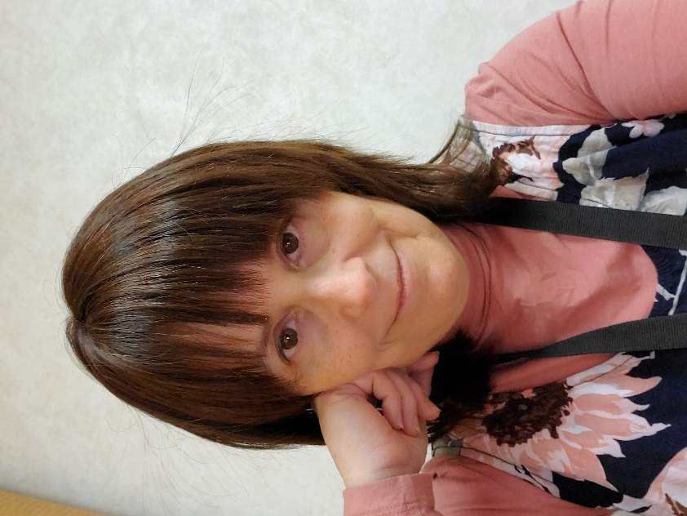

- Therapy services are available via telehealth from anywhere in Pennsylvania, and in person at select locations.

- Weekend and evening appointments are available (7 am through 7 pm).

- Many major insurance plans and Employee Assistance Plans (EAPs) are in-network.

- For depression, anxiety, grief, adjustment to life changes, relationship issues, trauma recovery, insomnia, nightmares, or something unique to you: see if some sessions with an experienced therapist will help.

Su Siegelman, LCSW

CVS Health | Minute Clinic
6701 Ridge Avenue, Philadelphia PA 19128
215-483-4179, then hit 8226 , or cell: 401-208-6046

Susan.Siegelman@minuteclinic.com

“Sometimes life gets crazy……but we don’t have to be.”

To schedule, call
1-855-417-2486 or go to
https://www.cvs.com/minuteclinic/services/mental-health-counseling

